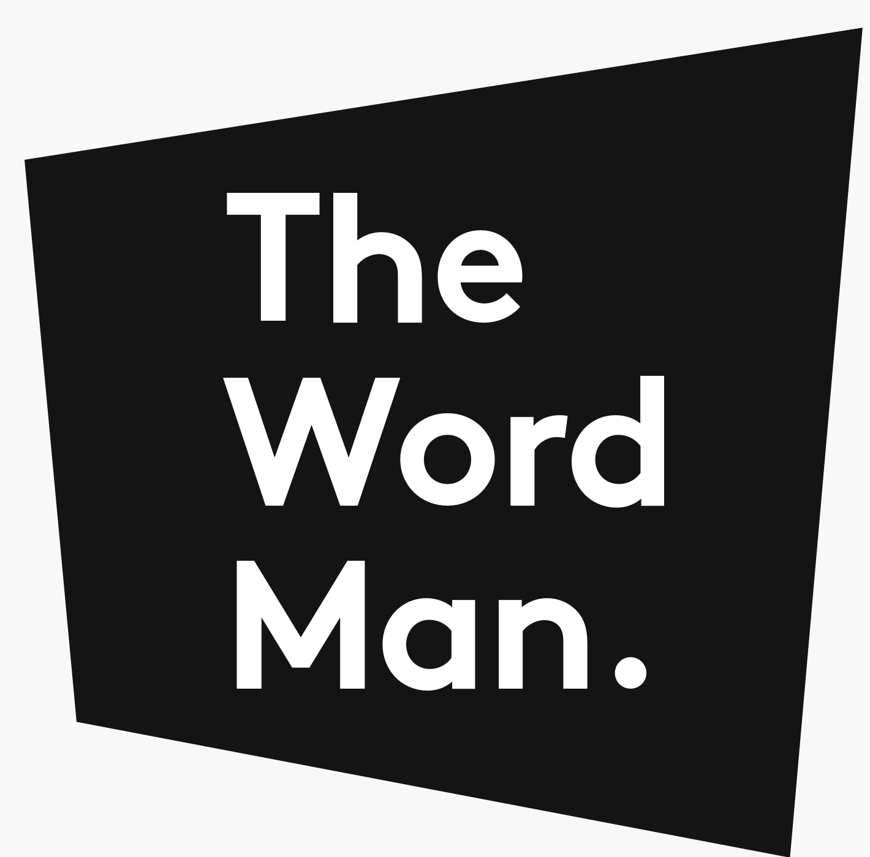

Copywriting brief
I know filling in forms is a pain, but the more info you give me now, the less I’ll badger you in future.
Your answers will help me understand exactly what you do, who your customers are, and what words you need.

Your name
Your company
Today’s date
First draft needed by
Go-live date

1. Describe what your company does, in plain English.

For example: “We are a factory, we manufacture phone handsets, we have been operating in Liverpool since 1995.” Please avoid buzzwords and business-speak (e.g. “we provide solutions”)

2. How are your clients’ lives/businesses made better by your product/service?

For example: “The bicycles we sell from our online shop get you from place to place faster than walking, but cost less than a car, and are better for the environment! Best of all, we deliver!”

3. What do you want me to create?

For example: “I’m selling a new range of travel gift cards and I need a tagline to go on the cards, 3 x 200-word customer emails focusing on different destinations, and a 600-word website landing page.”

4. What do you want to achieve with the copy?

For example: “To attract new customers, or retain old customers, or make our brand sound more modern, or and position ourselves as a ‘premium’ brand so we can charge a bit more.”

5. Who’ll be reading the copy? How do they buy your product or service? And what do they think about your brand now?

For example: “Our clients work in senior management roles, under constant pressure from the board to get things done quickly. They come to us via Linkedin ads, Google or referrals. They see us as just one of many options in our sector.”

6. What do you want people to think, feel and do after reading the copy?

For example: “Think: These seem like a fun team who’ll be easy to work with. Feel: Peace of mind that you’ll get the job done. Do: Book a call.”

7. What are your key messages?
Provide as much detail about all of the important stuff you’d like to say in the copy, plus:
- Paragraph or word counts and formatting ideals (long paras, bullets etc)
- URLs of any existing content you’d like me to rewrite or reference
- Specific keywords/phrases you’d like to use or AVOID

8. Why should the audience believe these key messages?

Tell me about your unique selling points. Provide some tangible proof points like facts and statistics.
For example: “we are 50% cheaper than our nearest competitor, we sell our product in more colours, our product is proven more reliable and lasts twice as long.”

9. How do you want the copy to “sound”? (Your tone of voice)

Pick one, or a few, or create your own (and explain why): Authoritative. Caring. Casual. Dramatic. Dreamy. Dry. Edgy. Energetic. Enthusiastic Formal. Frank. Funny. Humble. Light-hearted. Playful. Provocative. Quirky. Respectful. Sarcastic. Scientific. Serious. Storytelling. Upbeat. Wild. Witty.

10. Who are your main competitors, and what do you do that they don’t?

List their names and their strengths, along with the things that make you better or different than them.

11. Do you have images, wireframes or a sitemap that may help me?

For example: a sitemap that shows the layout of your website and the number of pages that need copy, or a wireframe template so I can see where the copy will sit on the page.

If so, please attach these when you send me this brief.

---------------------------------------------------

Thank you – that’s it!

Please return this brief to dave@thewordman.co.uk.

If there’s anything else to add, just include it in your email.

